Module 3: ANOVA and Gauge Repeatability & Reproducibility
- ANOVA Generalities: Understand Analysis of Variance, or ANOVA, as a statistical method used to determine whether one or more categorical predictors have a statistically significant effect on a continuous response variable. Students should be able to:
  - Explain the meaning of the acronym ANOVA.
  - Identify situations in which ANOVA is appropriate, including comparing the mean performance of several groups, datasets, treatments, machines, materials, or operating conditions.
  - Recognise that ANOVA evaluates differences between group means by comparing variation associated with the predictors against unexplained or random variation.
  - Distinguish one-way, two-way, and higher-order ANOVA according to the number of predictors included.
  - Recognise that ANOVA can investigate both the individual effects of predictors and, when applicable, interactions between predictors.

- One-Way ANOVA: Understand one-way ANOVA as a model involving one categorical predictor and one continuous response variable. The observed response is represented as the combination of an overall mean, a treatment or group effect, and random error.
Students should be able to:
  - Identify the response variable, the categorical predictor, and the groups or treatment levels.
  - Formulate the null hypothesis that all population group means are equal means ($H_{0}$ as the equality of all group means).
  - Formulate the alternative hypothesis that at least one population mean differs from the others ($H_{A}$ as at least one mean is different to the others).
Students also need to express $α$ and $β$ risk levels and sample sizes used for the ANOVA.
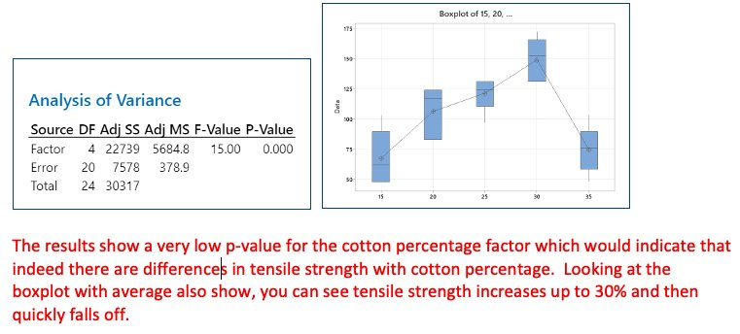
- ANOVA Table: Understand that ANOVA separates the total variation observed in the response into variation explained by differences between groups and variation remaining within the groups (noise). Students should be able to:
  - Interpret the principal components of an ANOVA table: source of variation, sum of squares, degrees of freedom, mean square, (F)-statistic, and (p)-value.
  - Understand sum of squares as a measure of variability around a reference mean.
  - Distinguish between-group variation, which represents the effect associated with the predictor, from within-group variation, which represents residual or unexplained variability.
  - Understand that the (F)-statistic compares explained variation with residual variation.
  - Compare the (p)-value with a selected significance level, commonly (0.05).
  - Reject the null hypothesis when the (p)-value is below the significance level.
  - State that there is insufficient evidence to reject the null hypothesis when the (p)-value is greater than or equal to the significance level. Students should not describe this result as proving or accepting the null hypothesis.
  - Recognise that a statistically significant ANOVA result indicates that at least one mean differs but does not identify which groups differ without further analysis, such as post-hoc comparisons.
- Model Adequacy and Residual Analysis: Students must be able to Assess the adequacy of an ANOVA model before drawing conclusions from its sums of squares, (F)-statistics, or (p)-values. Statistical conclusions are only reliable when the model provides a reasonable representation of the data.
Students should be able to:
  - Interpret residuals as the differences between observed and model-predicted values.
  - Examine residual plots to assess whether errors are randomly distributed around zero.
  - Check whether residual variability remains approximately constant across fitted values and groups.
  - Assess whether residuals are approximately normally distributed, while recognising that apparent non-normality may arise from a small sample size.
  - Check the independence of residuals, particularly when observations have been collected over time.
  - Identify outliers and understand that they require engineering and statistical investigation rather than automatic removal.
  - Recognise curved or systematic residual patterns as possible evidence of missing terms, incorrect model structure, transformations, or relationships not represented by the model.
  - Recognise residual trends over time as possible evidence of drift, degradation, environmental effects, or omitted time-related predictors.
  - Consider adding relevant factors or interactions when important sources of variation appear to be omitted.
  - Consider transformations, such as a natural logarithm or Box–Cox transformation, when variance or distributional assumptions are not satisfied.
  - Use the mean square error and adjusted coefficient of determination as supplementary indicators of model adequacy.
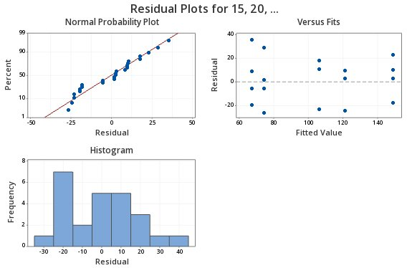
- Two-Way ANOVA: Understand two-way ANOVA as an extension of one-way ANOVA involving two categorical predictors and one continuous response variable.
Students should appreciate the possibility to include an interaction term in a Two-Way ANOVA.
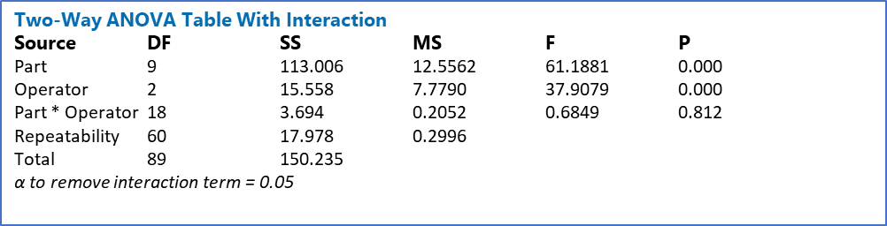
- Measurement Error: Understand that the variation observed in manufacturing or experimental data includes variation from the underlying process and variation introduced by the measurement system:
Observed Variability = Process Variability + Measurement Variability
Students should also appreciate that if the measurement variability is similar to the process variability, wrong decisions will be made. As such, the measurement systems must be analysed.
Outcomes of the measurement system analysis should outline the magnitude of the measurement error, its contributors, the stability of the measurement system and pathways to improvements.
- Measurement System Metrics: Understand the principal characteristics used to evaluate a measurement system and interpret the results of a Gauge Repeatability and Reproducibility study. Students should be able to distinguish:
  - Accuracy: the closeness of a measurement or average measurement to an accepted reference value.
  - Bias: the systematic difference between the average measured value and the accepted reference value.
  - Resolution: the smallest increment or change that the measurement system can display or distinguish.
  - Repeatability: variation observed when the same operator measures the same part repeatedly using the same instrument, method, and conditions.
  - Reproducibility: variation associated with changes in operators, instruments, laboratories, fixtures, or other measurement conditions.
  - Stability: changes in measurement bias or variation over time.
  - Linearity: changes in measurement bias across the operating range of the instrument.
Students should understand that a measurement system must be repeatable, i.e. having little standard deviation from successive measurements, of the same part, by the same person, using the same instrument. Students must also understand the need for reproducibility, which is having little standard deviation over different conditions. Reproducibility can be impacted by changing from one instrument to another, aging instruments, or from operator to operator.
- Precision: Students must understand the difference between accuracy and precision. Understand precision as the closeness of repeated measurements to one another, independently of whether those measurements are close to the true value.:
$$Precision= σ_{repeatability}^{2}+σ_{reproducibility}^{2}$$
Students understand Precision is also called Gage R&R or measurement error and is the primary metric of a measurement system analysis.
- Stability: Students must understand stability as the measurement system drift over time, which can impact either accuracy or precision. Stability is monitored using repeated GRR studies. Usually, $σ_{measurement}$ is plotted over time. A non-stable measurement is called inconsistent.
- Linearity: Students must understand linearity as the difference in accuracy or precision over the domain of the device. If the measurement is large, is the error bigger than when the measurement is small?
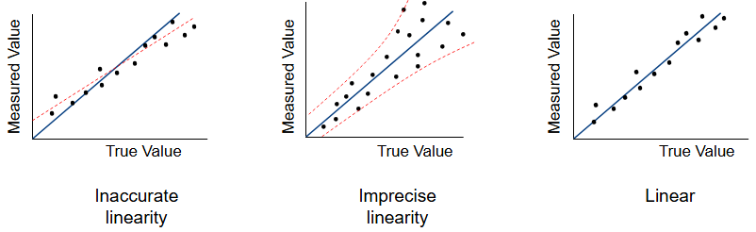
- Process Variation Based Metrics: Students should be familiar with concepts of Precision-to-total variation:
$$\frac{P}{TV}=\frac{σ_{meas}}{σ_{tot}}=\frac{σ_{meas}}{σ_{process}+σ_{meas}}$$
And Percent R&R:
$$\%R\&R=\frac{σ_{meas}^{2}}{σ_{total}^{2}}*100$$
Student should interpret both metrics as quantification of the total variation (observed variation) due to measurement error. %RR is better statistically.
Students should also be familiar with the concept of discrimination, as the number of distinct measurements system variances that can fit in the total variance:
$$Discrimination= \sqrt{2\frac{σ_{total}^{2}}{σ_{meas}^{2}}-1}$$
- Gauge Study Interpretation: Students should be able to interpret the results of a gage study:
Rating | P/TV | %RR | Discrimination
Unacceptable | >30% | >9% | <5
Bad | 10-30% | 2-9% | 5-10
Good | 0-10% | 0-2% | >10
The students should also be aware that to obtain reliable Gauge R&R study results, the experiment should be conducted over 3 operators, 3 repeats each, on 10 parts, leading to 90 total runs, which is an industry standard.
Students should be able to interpret the results of the Gauge R&R table:
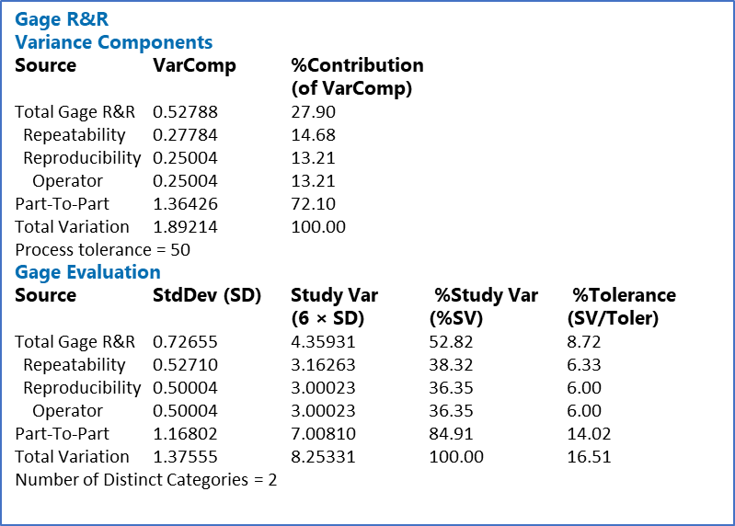
P/TV (SV/Tol) answers “Can I use the measurement system to inspect parts?”, the answer of which is relative to the tolerance specifications.
The %RR (%SV) answers “Can I use the measurement system to see a process shift?”, the answer of which is relative to the process shift.
The visual interpretation of the Gauge R&R is also important:
